**Azure Traffic Manager**

The role of Azure Traffic Manager is to act as a DNS-based traffic load balancer, distributing incoming traffic across multiple endpoints (like Azure services or on-premises servers) based on various routing methods. This enhances the availability and performance of your web applications.

Azure Traffic Manager offers several routing methods to distribute traffic effectively:

* **Priority:**
  + Routes traffic to the highest-priority endpoint first.
  + If the primary endpoint is unavailable, it moves to the next highest priority, and so on.
  + Useful for scenarios where high availability for a specific endpoint is critical.
* **Weighted:**
  + Distributes traffic across endpoints based on assigned weights.
  + Higher weights mean a higher proportion of traffic will be directed to that endpoint.
  + Useful for load balancing across multiple endpoints with varying capacities.
* **Geographic:**
  + Routes traffic to the endpoint closest to the user's geographic location.
  + Ensures faster response times and a better user experience by minimizing latency.
  + Useful for applications with regional user bases or data sovereignty requirements.
* **Performance:**
  + Routes traffic to the endpoint with the best performance based on latency and other factors.
  + Continuously monitors endpoint performance and dynamically adjusts routing accordingly.
  + Ideal for optimizing application performance and user experience.
* **MultiValue:**
  + Returns multiple healthy endpoints in the DNS response.
  + Allows clients to connect to any of the returned endpoints, improving reliability and fault tolerance.
* **Subnet:**

The **Subnet Routing Method** allows you to direct traffic to specific endpoints based on the source IP address range of the incoming requests.

By carefully selecting the appropriate routing method, you can optimize your application's performance, availability, and user experience based on your specific needs and requirements.

Features of Azure Traffic Manager:

1. It supports globally so it is commonly known as Global LOAD Balancer.
2. It works on DNS based traffic routing principle.
3. It routs the traffic using Routing Methods.
4. It is operated in layer-7 of OSI model (application).
5. Here DNS name is assigned to load balancer. Not the private or public IP.

**Note:** In DNS domain name to domain name mapping is known as C name record (Canonical Name).

**Benefits of using Azure Traffic Manager:**

* **Improved Availability:** Reduces downtime and increases resilience.
* **Enhanced Performance:** Provides faster response times and better user experience.
* **Cost Optimization:** Optimizes resource utilization by distributing traffic efficiently.
* **Simplified Management:** Centralized management of traffic routing and endpoint monitoring.
* **Scalability:** Easily scales to accommodate growing traffic demands.

**In summary:**

Azure Traffic Manager plays a crucial role in ensuring the reliability, performance, and availability of your web applications by intelligently distributing traffic across multiple endpoints. It is a valuable tool for businesses of all sizes looking to improve their online presence and deliver a better user experience.

Block Diagram:

Global123.trafficmanager.net

**Internet**

Traffic Manager

**Central India-RG**

**East-RG**

**USER**

**Central India**

**East US**

Vnet

Vnet

Web01

Web02

Web01

Web02

AZLB

AZLB

Azureadmin.xyz

Fig: Block diagram of Azure Traffic Manager.

The above figure does not shows the original work flow of the Azure Traffic Manager.

The original real work flow of the Azure traffic manager is shown below figure.

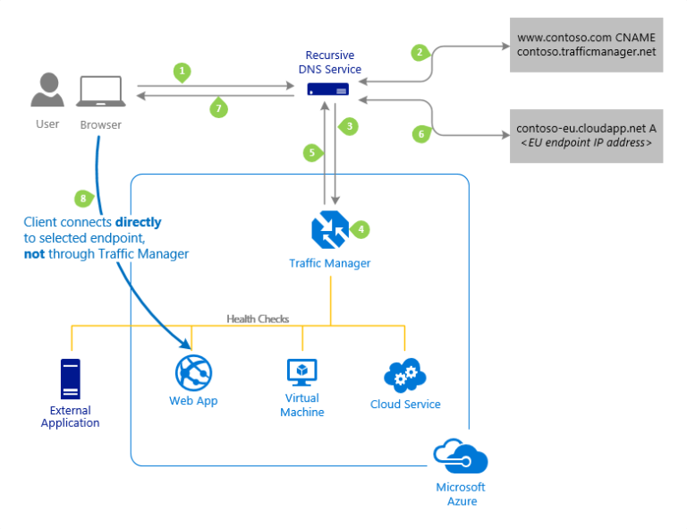

Fig: The Azure Traffic manager work flow.

**Note1:** In the concept of Azure Traffic Manager the user directly connects to the Endpoint (Backend pool), not through the Traffic manager as show in above figure.

That means a traffic manager cannot route the traffic. Traffic Manager analyzes the request and determines the best endpoint to direct the user based on the configured routing method.

**Note2**: While creating the Global Load Balancers (Traffic Manager) it is mandatory to create or configure the internal regional load balancers in different RG. This internal load balancers IP’s are become endpoint’s.

Let’s create the Azure Traffic Manager:

**Step1:** Create the Resource Group (RG01).

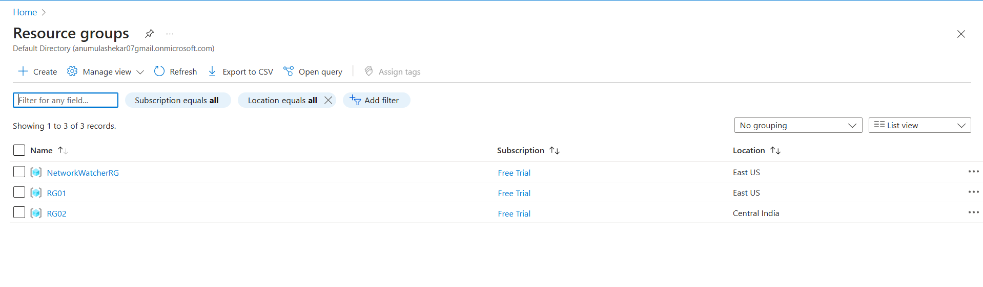

**Step2:** Create the two virtual machines in two different regions & Resource Groups.

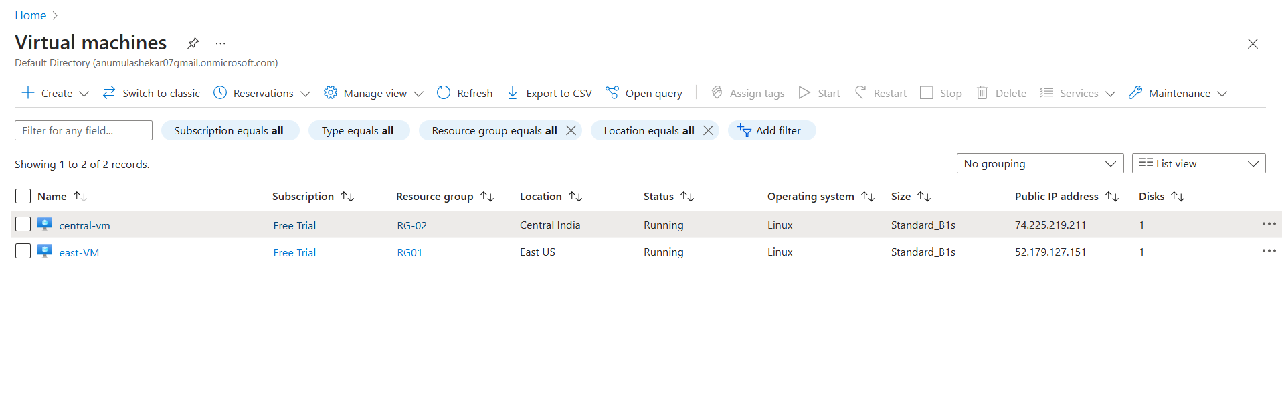

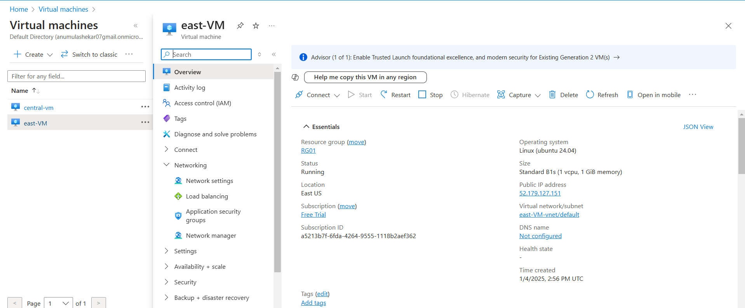**Note:** We know that Azure Traffic Manager works on DNS based routing principle so instead of using Public IP let’s configure the DNS name to the VM’s.

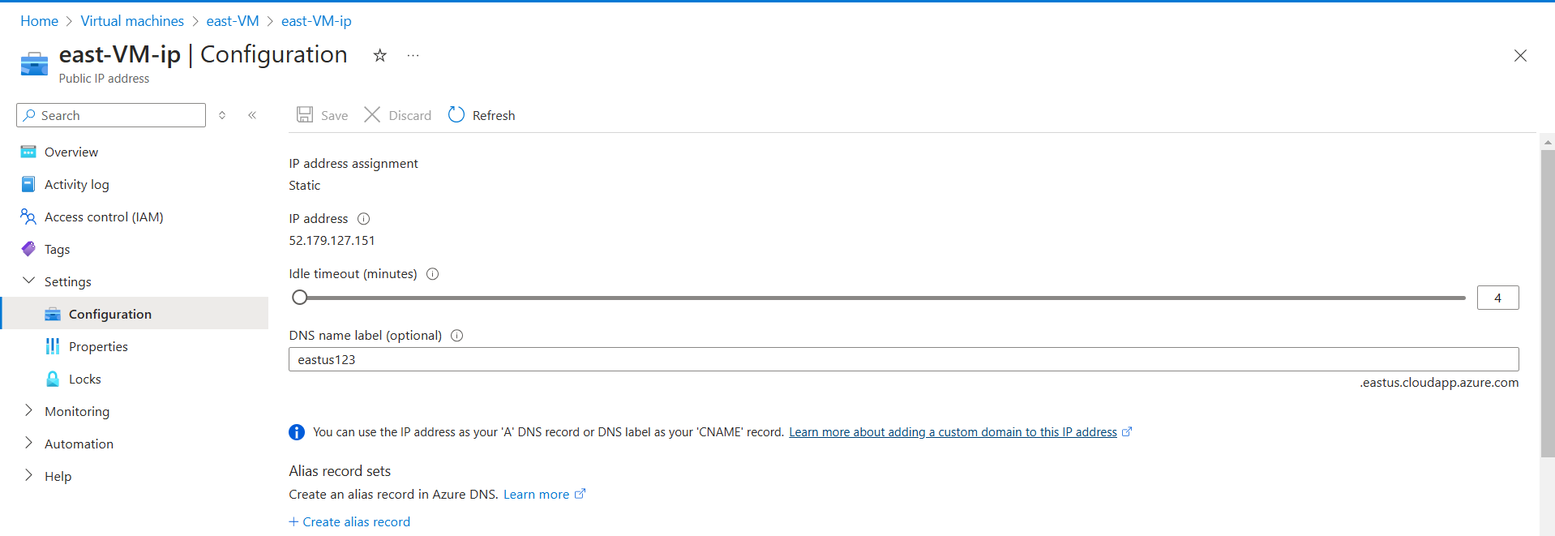

Similarly configure the DNS name to the other VM (central-vm) also.

Step3: Create the Azure Traffic Manager.

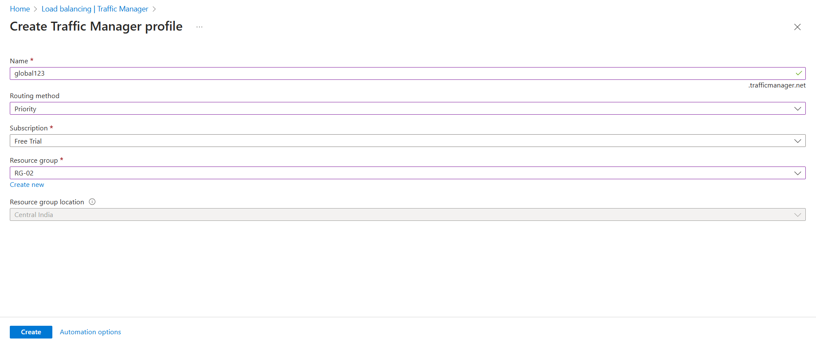

Note: A traffic manager can be created in any resource group (RG01 & RG-02).

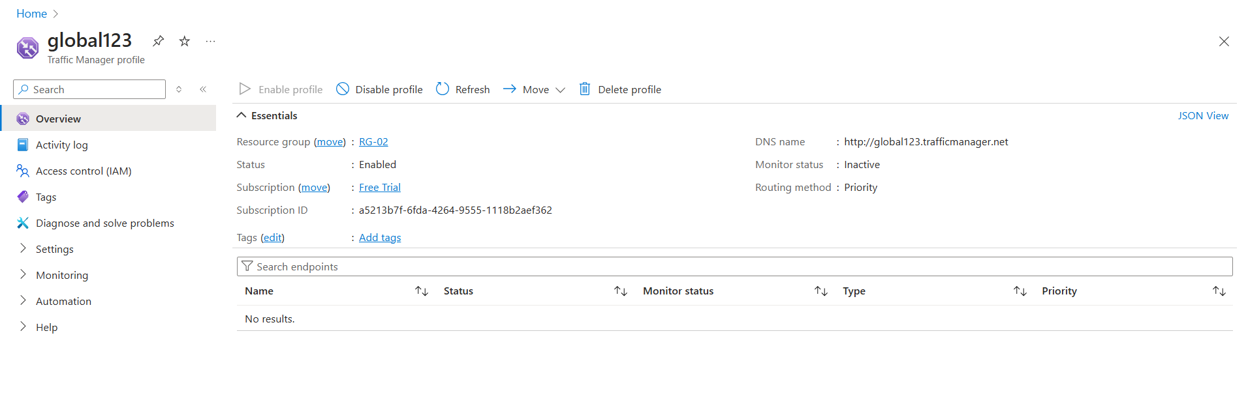

Step4: Configure the endpoints in Traffic Manager.

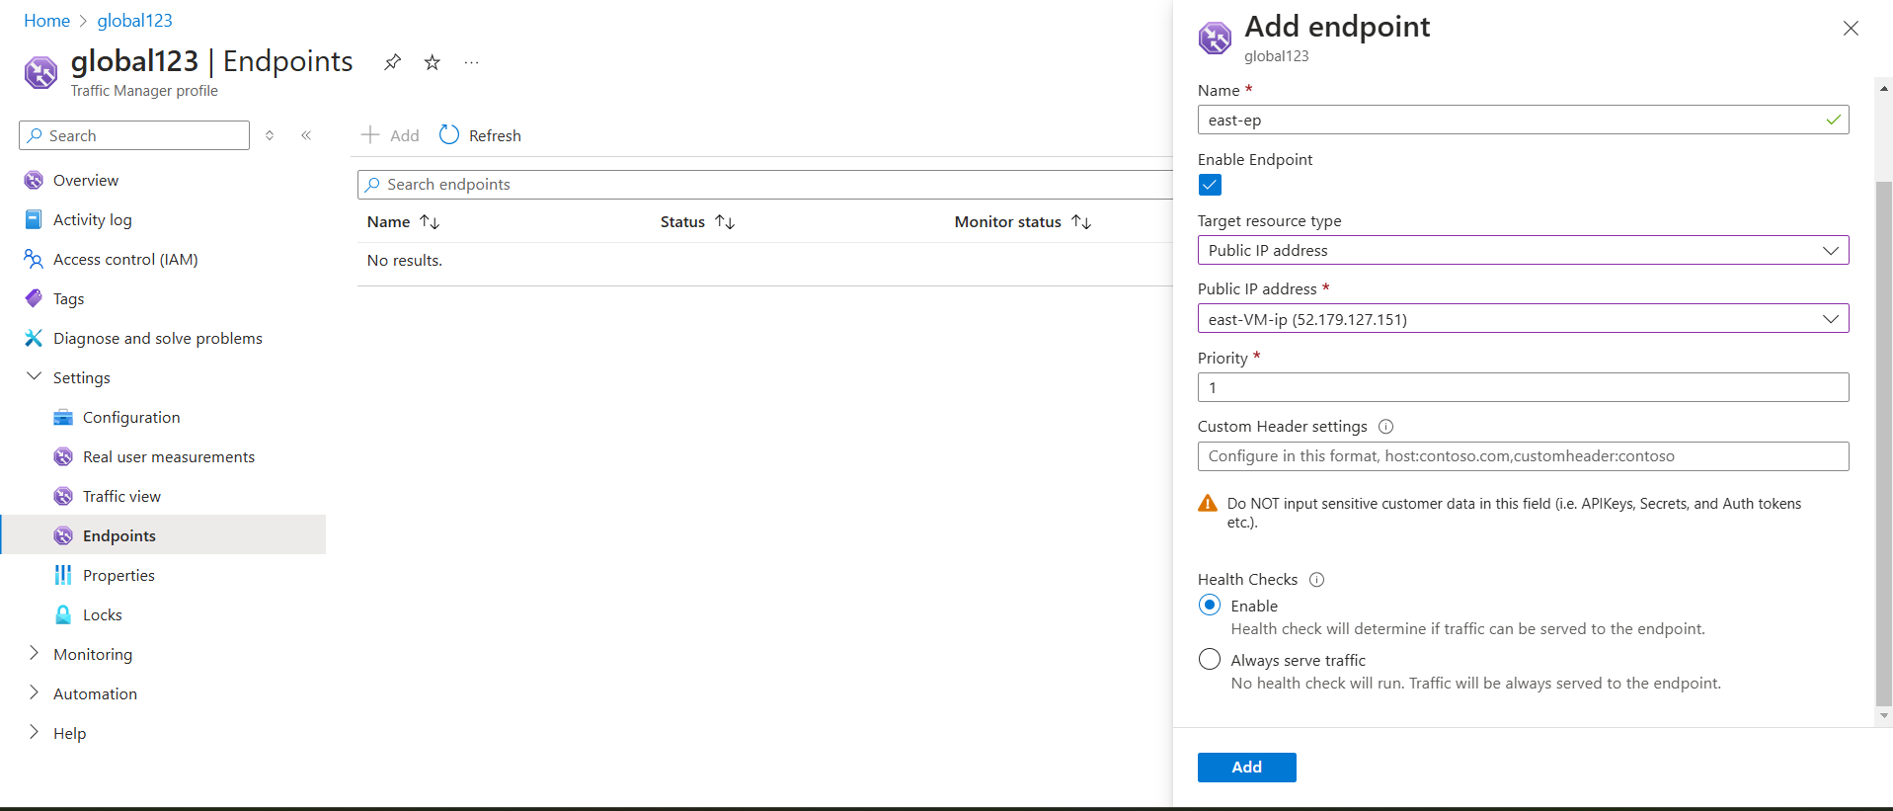

Fig: East-VM Endpoint with priority=1.

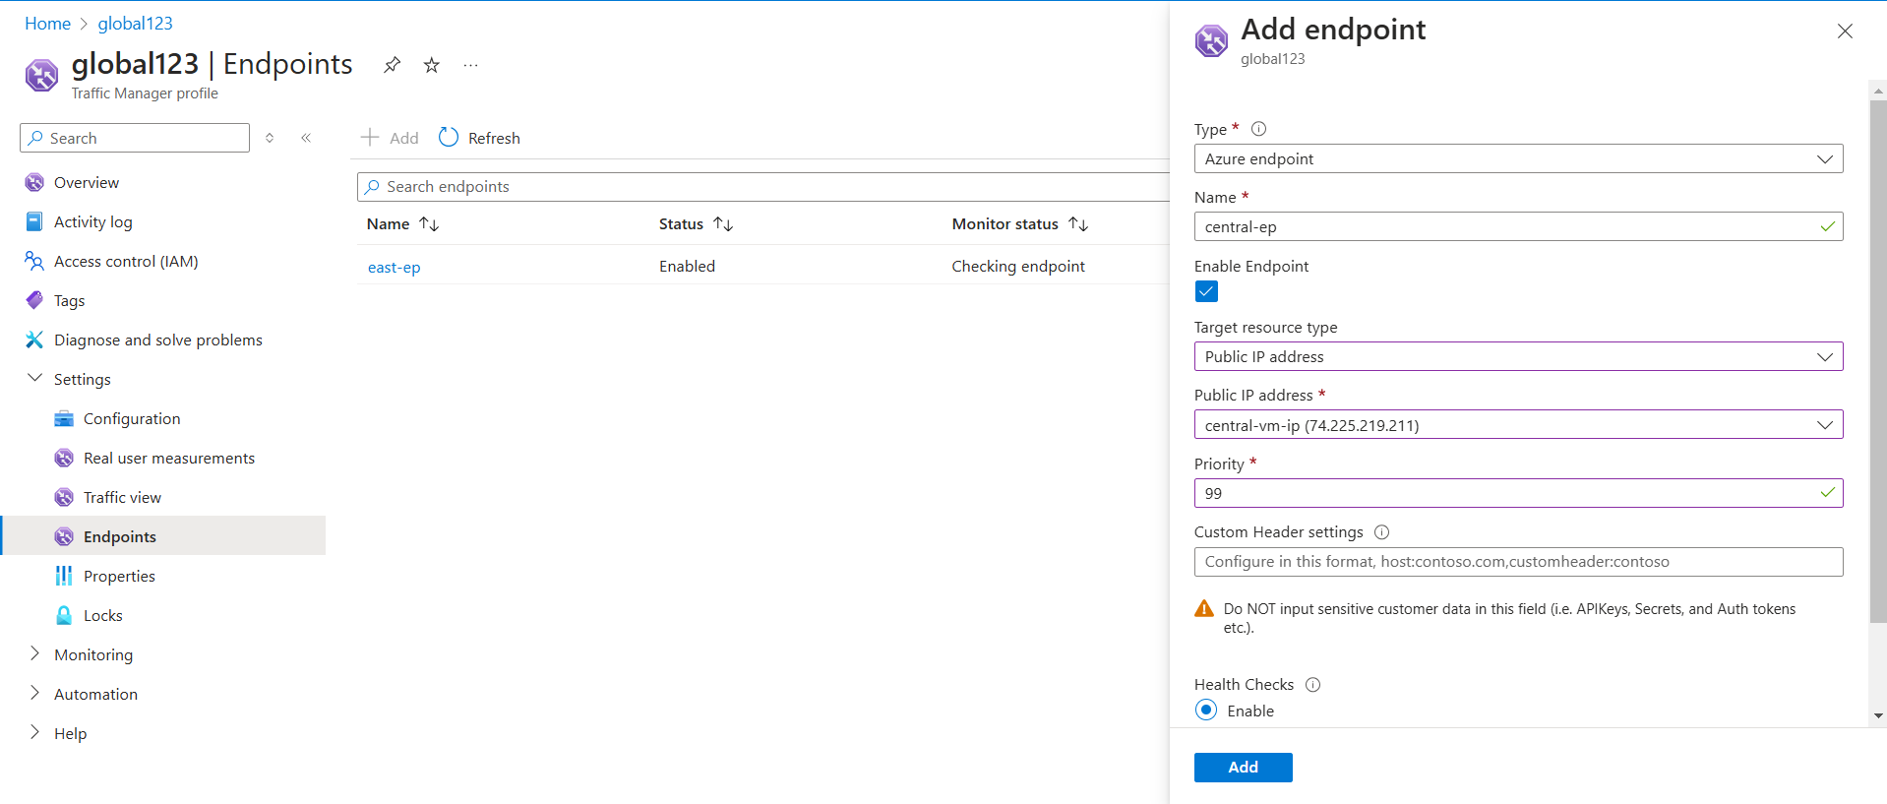

Fig: central India-VM endpoint with priority=99

**Step5:** Now brows in any browser with DNS name of Traffic manager (global123.trafficmanger.net).



Similarly if change the priority of east-us VM as “100” and central-India VM as “1”. Then it will display central Indian web server page with DNS name.



The different routing methods can be configure using configuration option in the Traffic Manger as shown in below figure.

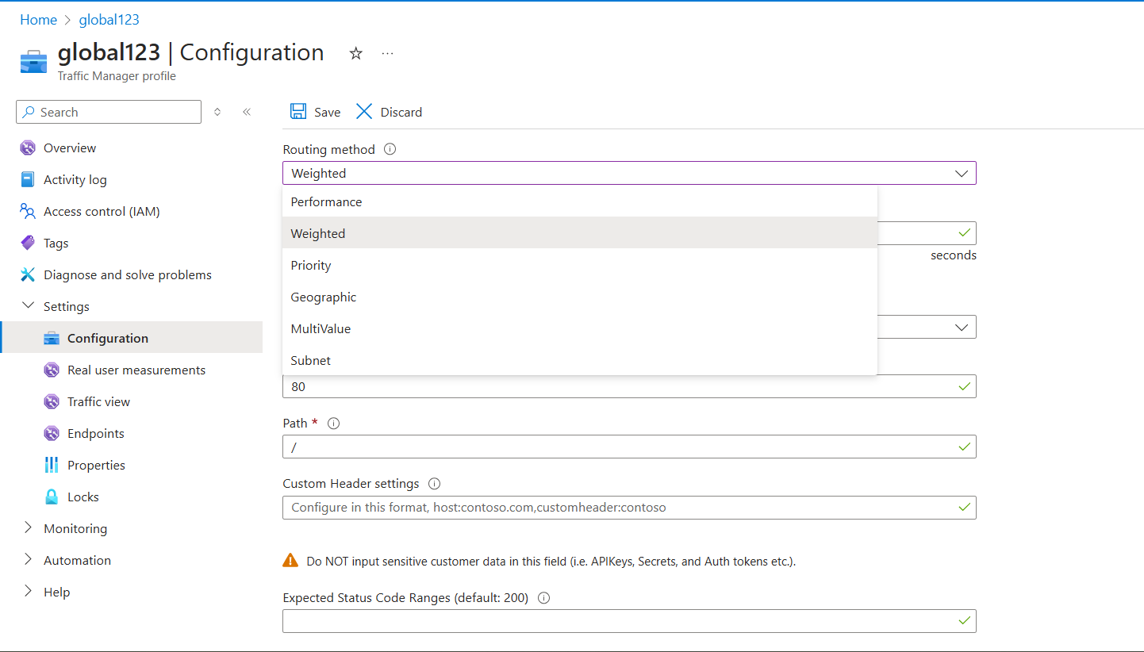

Let’s check the weightage routing method.

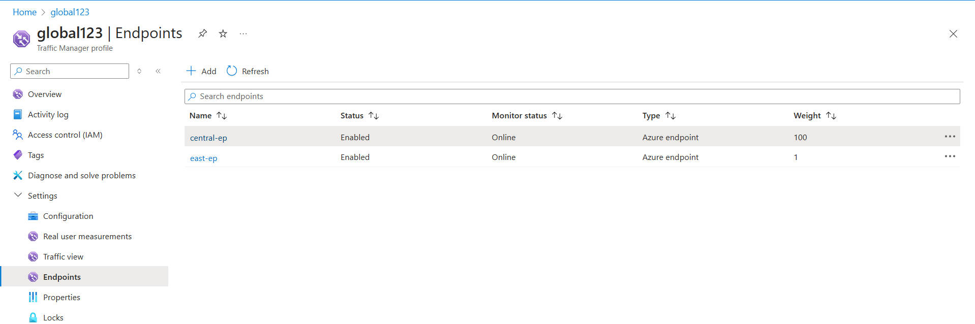

Now change the weightage between two VM’s.

